**How To Install Grafana on RHEL 8**

login as: root

root@192.168.0.153's password:

Access denied

root@192.168.0.153's password:

Activate the web console with: systemctl enable --now cockpit.socket

Register this system with Red Hat Insights: insights-client --register

Create an account or view all your systems at https://red.ht/insights-dashboard

Last login: Mon Nov 14 07:55:32 2022

**Step 1: Add Grafana 8 YUM repository**

**[root@servera ~]# vim /etc/yum.repos.d/grafana.repo**

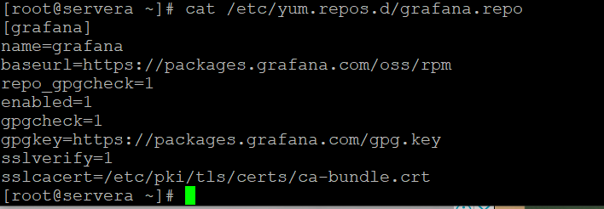

[root@servera ~]# cat /etc/yum.repos.d/grafana.repo

[grafana]

name=grafana

baseurl=https://packages.grafana.com/oss/rpm

repo_gpgcheck=1

enabled=1

gpgcheck=1

gpgkey=https://packages.grafana.com/gpg.key

sslverify=1

sslcacert=/etc/pki/tls/certs/ca-bundle.crt

You can optionally update you cache index for available packages:

**[root@servera ~]# sudo dnf makecache**

Updating Subscription Management repositories.

grafana 42 B/s | 454 B 00:10

grafana 322 B/s | 1.7 kB 00:05

Importing GPG key 0x24098CB6:

Userid : "Grafana <info@grafana.com>"

Fingerprint: 4E40 DDF6 D76E 284A 4A67 80E4 8C8C 34C5 2409 8CB6

From : https://packages.grafana.com/gpg.key

Is this ok [y/N]: y

grafana 1.4 MB/s | 24 MB 00:17

Red Hat Enterprise Linux 8 for x86_64 - BaseOS 649 B/s | 4.1 kB 00:06

Red Hat Enterprise Linux 8 for x86_64 - BaseOS 3.5 MB/s | 55 MB 00:15

Red Hat Enterprise Linux 8 for x86_64 - AppStream (RPMs) 736 B/s | 4.5 kB 00:06

Last metadata expiration check: 0:00:01 ago on Mon 14 Nov 2022 08:07:29 AM EST.

Metadata cache created.

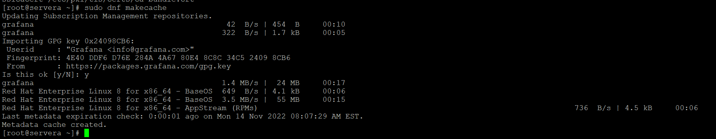

Step 2: Install Grafana 8 on RHEL 8

**[root@servera ~]# sudo dnf -y install grafana**

C:\Users\harish\Desktop\grafan3.png

Updating Subscription Management repositories.

Last metadata expiration check: 0:01:34 ago on Mon 14 Nov 2022 08:08:27 AM EST.

Dependencies resolved.

=============================================================================================================================================================

Package Architecture Version Repository Size

=============================================================================================================================================================

Installing:

grafana x86_64 9.2.4-1 grafana 91 M

Transaction Summary

=============================================================================================================================================================

Install 1 Package

Total download size: 91 M

Installed size: 308 M

Downloading Packages:

grafana-9.2.4-1.x86_64.rpm 8.7 MB/s | 91 MB 00:10

-------------------------------------------------------------------------------------------------------------------------------------------------------------

Total 8.7 MB/s | 91 MB 00:10

grafana 222 B/s | 1.7 kB 00:07

Importing GPG key 0x24098CB6:

Userid : "Grafana <info@grafana.com>"

Fingerprint: 4E40 DDF6 D76E 284A 4A67 80E4 8C8C 34C5 2409 8CB6

From : <https://packages.grafana.com/gpg.key>

Key imported successfully

Running transaction check

Transaction check succeeded.

Running transaction testTransaction test succeeded.

Running transaction

Preparing : 1/1

Installing : grafana-9.2.4-1.x86_64 1/1

Running scriptlet: grafana-9.2.4-1.x86_64 1/1

### NOT starting on installation, please execute the following statements to configure grafana to start automatically using systemd

sudo /bin/systemctl daemon-reload

sudo /bin/systemctl enable grafana-server.service

### You can start grafana-server by executing

sudo /bin/systemctl start grafana-server.service

POSTTRANS: Running script

Verifying : grafana-9.2.4-1.x86_64 1/1

Installed products updated.

Installed:

grafana-9.2.4-1.x86_64

Complete!

Package info:

**[root@servera ~]# rpm –qi grafana**

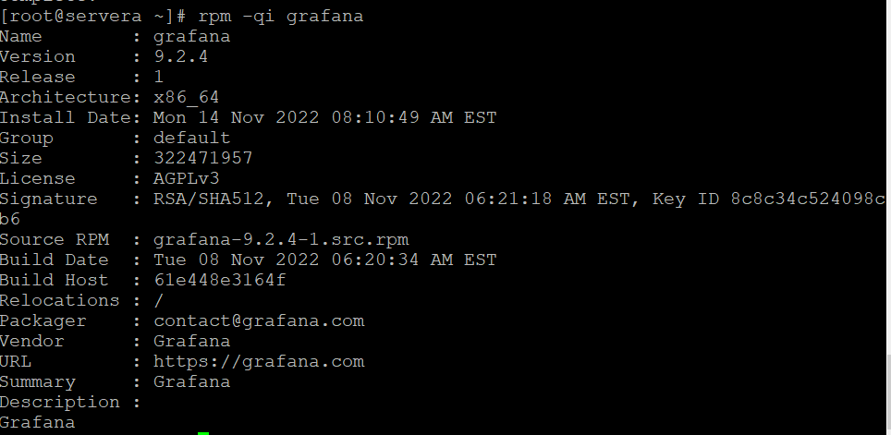

Step 3: Start Grafana Service

Grafana service is managed by systemd. Start the service and enable it to start on boot.

**[root@servera ~]# systemctl enable --now grafana-server.service**

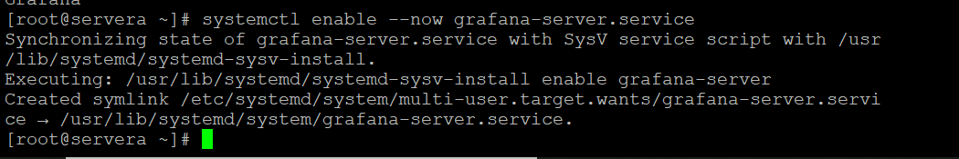

**[root@servera ~]# vim /etc/grafana/grafana.ini.**

http_port = 3000

The default port used is 3000. If you have another process using this port, you’ll need to set custom port in Grafana configuration file

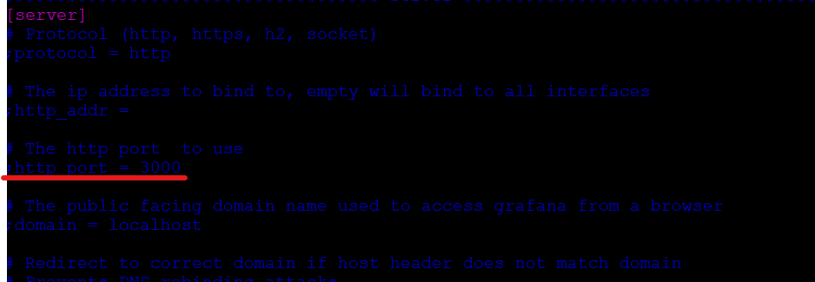

Your grafana-server service should show running state.

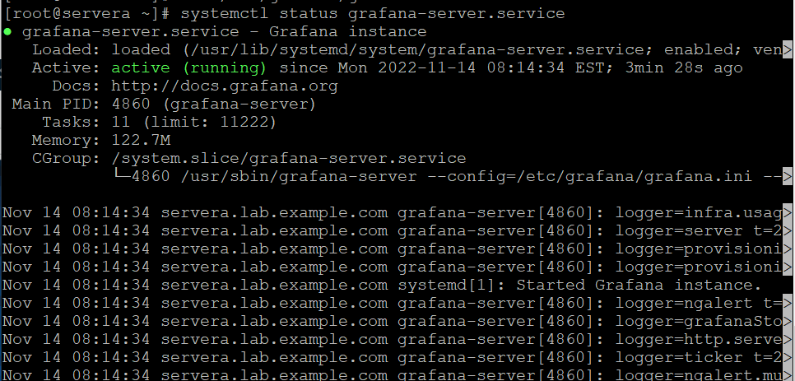

If you have a running firewalld service, allow port 3000for access to the dashboard from the network

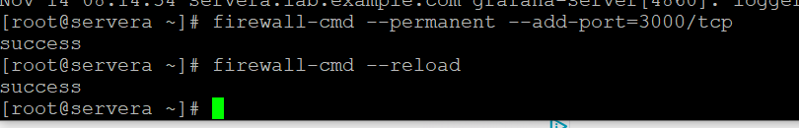

Step 5: Access Grafana Dashboard

Grafana web dashboard is accessible on <http://192.168.0.153:3000>

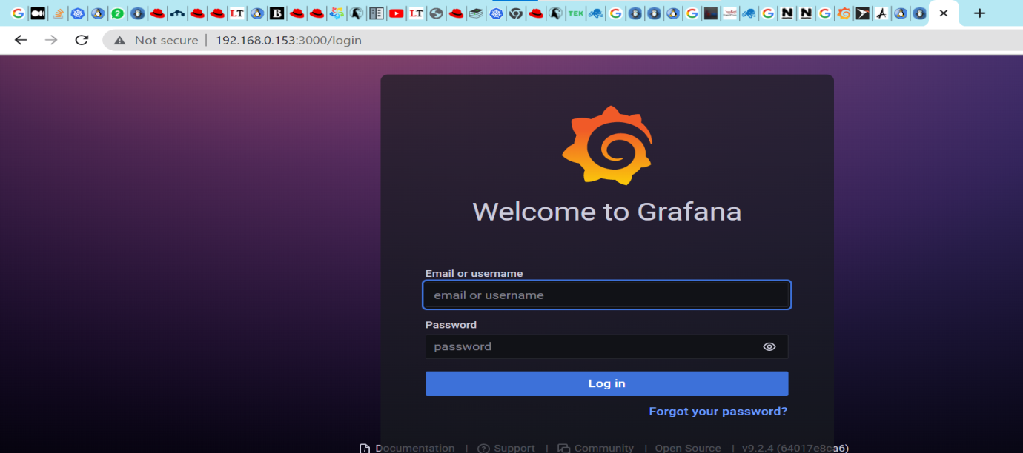

The default logins are:

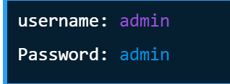

Change admin password in the next window.

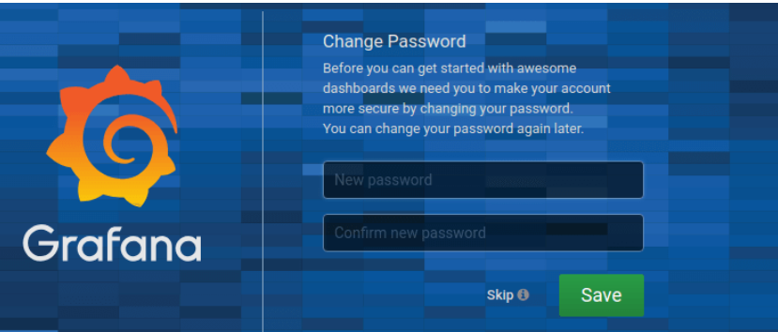

Now that you have Grafana installed in your RHEL 8 server, you can check our

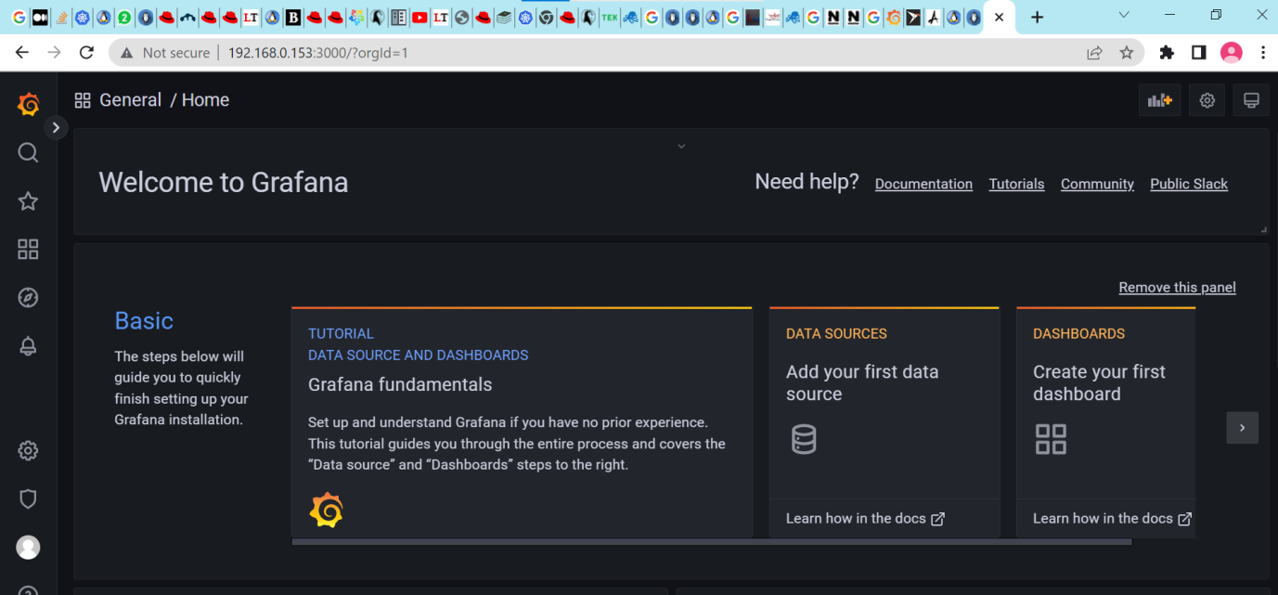Reference link

1. <https://computingforgeeks.com/how-to-install-grafana-on-rhel-8/>